Submit your employee’s incentive pay – for incentive employees only – do NOT use to record bonuses or other one-time payments

**Step 1:** Open the Incentive EIB for Managers located

[**Incentive EIB for Managers.xml**](http://training.wasteconnections.com/workday/Attachments/Manager/4.%20Payroll/1.%20Incentive%20Pay/Incentive%20EIB%20for%20Managers.xml)

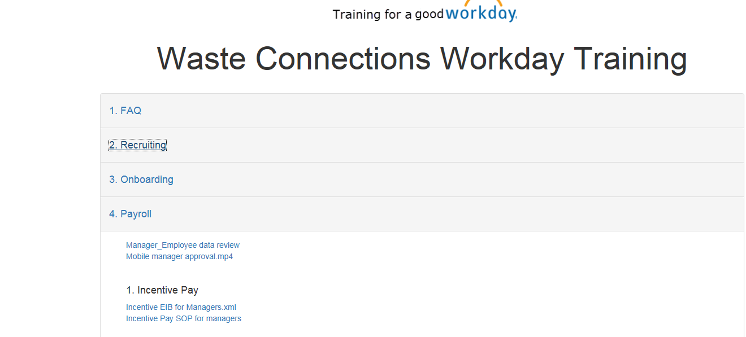

**Step 2:** On this spreadsheet, you will enter the **Pay Period Beginning** **Date** (column G) and **Pay Period Ending** **Date** (Column H) that the earnings apply to.

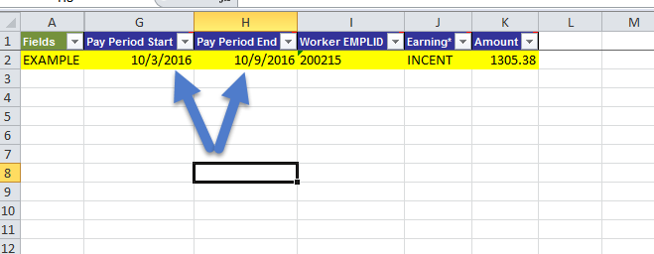

**Step 3:** Enter the employee’s new Workday Employee ID for **Worker EMPLID** (column I). Be sure to put an apostrophe ( ‘ ) in front of the number so it is entered as text. EMPLID’s should always be 6 digits.

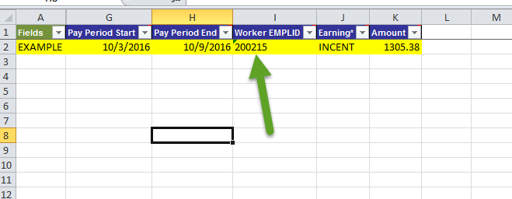

Step 4: Enter INCENT under Earnings (Column J).

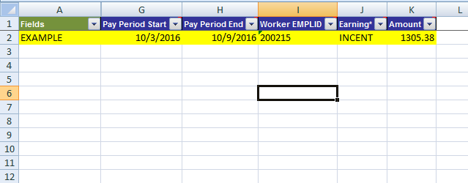

Step 5:The amount of the weekly incentive earnings should go under Amount (column K). Each week should go on a separate row.

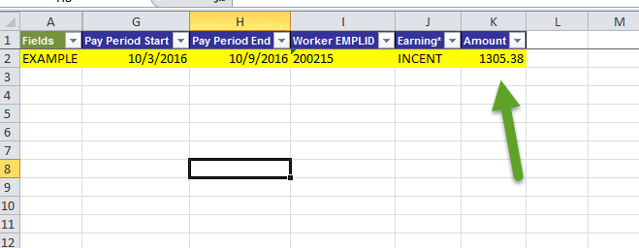

**Step 5:** Once you have entered all information for all incentive employees you will save and send the spreadsheet to your regional payroll email box at the following email addresses:

[**WesternPayroll@wasteconnections.com**](mailto:westernpayroll@wasteconnections.com)[**EasternPayroll@wasteconnections.com**](mailto:easternpayroll@wasteconnections.com)

**PayrollSouthern@wasteconnections.com**[**CentralPayroll@wasteconnections.com**](mailto:centralpayroll@wasteconnections.com)[**R360Payroll@wasteconnections.com**](mailto:R360payroll@wasteconnections.com)

**SPREADSHEETS MUST BE SUBMITTED TO YOUR REGIONAL PAYROLL BY 10AM CST MONDAY MORNING**